## UML Diagrams

### UML Use Case Diagram

### UML Activity Diagrams

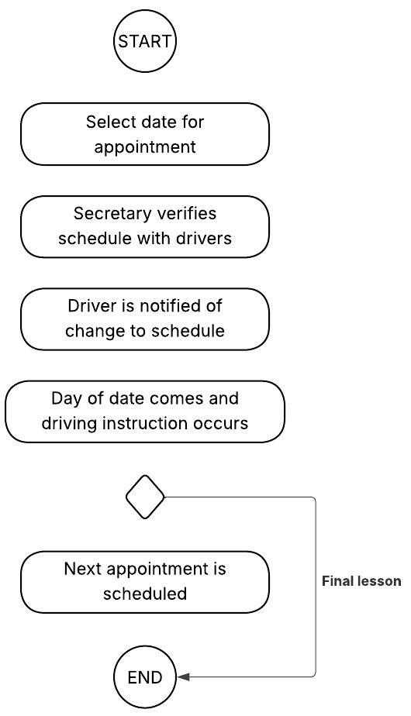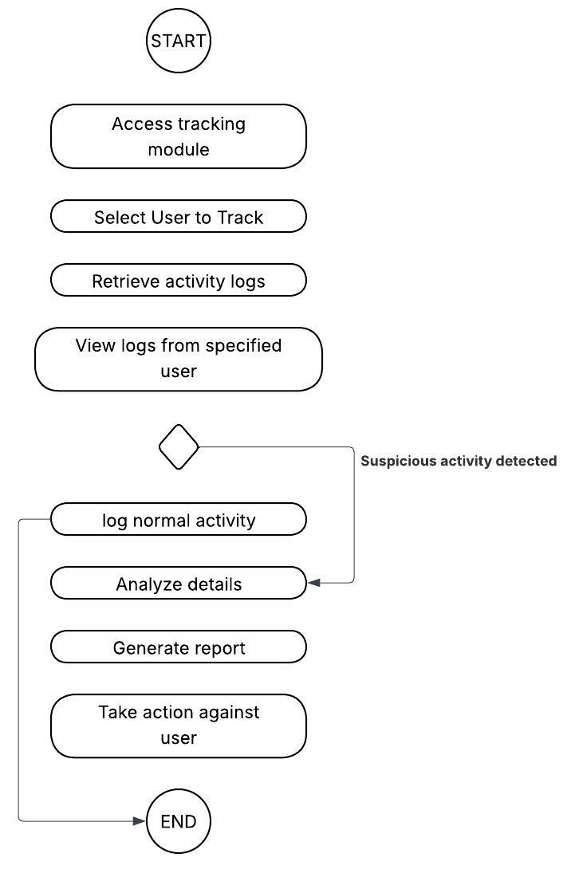

### These are activity diagrams for scheduling driving reservations (right) and tracking user activity (left)

### UML Sequence Diagram

**This is a sequence diagram for tracking user activity**

### A diagram of a computer flowchart AI-generated content may be incorrect.UML Class Diagram

## Technical Requirements

The DriverPass system requires a technical infrastructure to meet its business requirements. Examples include a cloud based, web accessible platform to support online driving training and reservation management. Hardware needs include client devices with minimal RAM and processing power, with major operating system compatibility and modern browsers, with a stable internet connection. Server side includes cloud servers, backed by redundant servers to mitigate downtime. Software includes a front end framework for a responsive interface, a backend for business logic, and a relational database like SQL with capacity for user data and reservations.

The infrastructure further requires a managed cloud service to eliminate backup and security burdens. Additional considerations include scalable storage for growth beyond 10 cars, compliance with credit card companies, and monitoring tools to alert admins of issues like failed logins. These requirements align with the use case diagram's actors and their functions, such as scheduling lessons and tracking activity, ensuring a secure, efficient system by the desired delivery date.